A1130-ME-Ephesus-Artemis-7th century replica

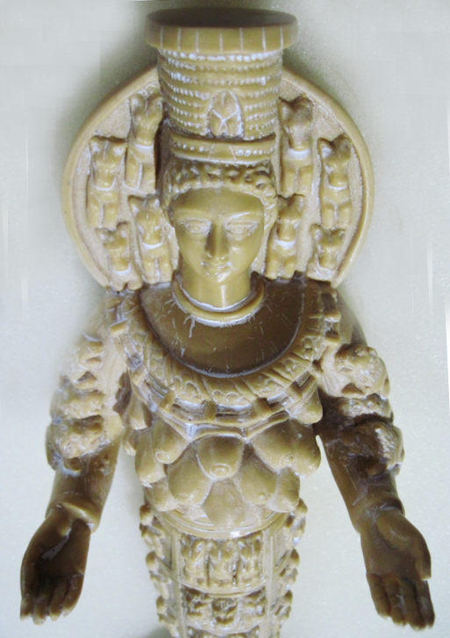 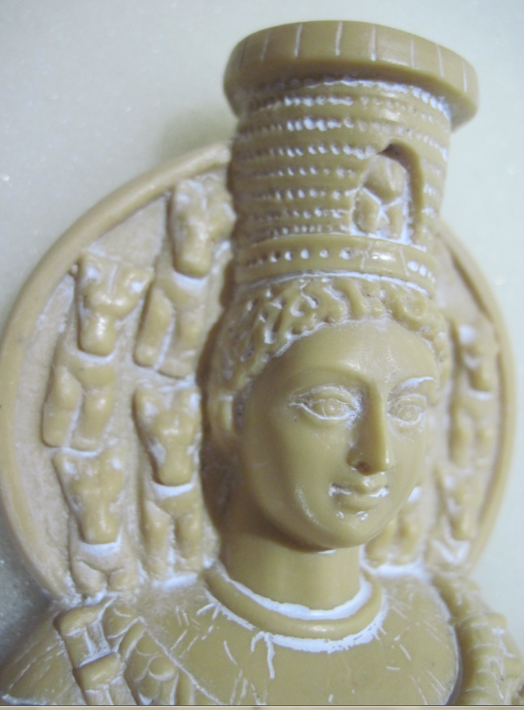 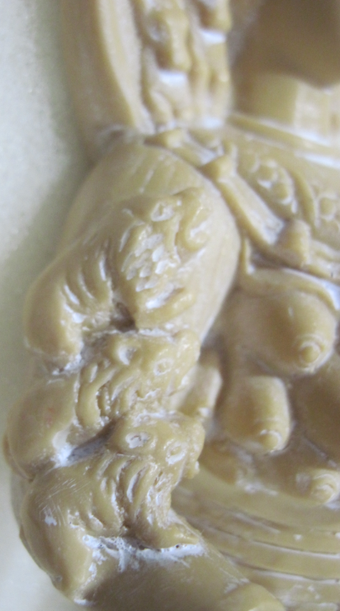

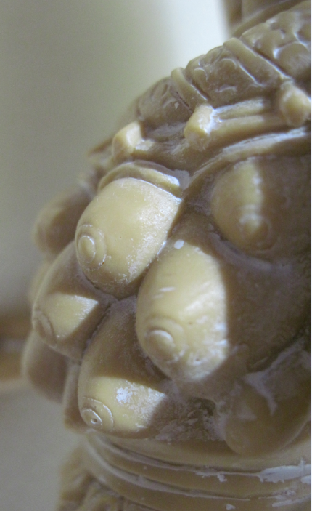 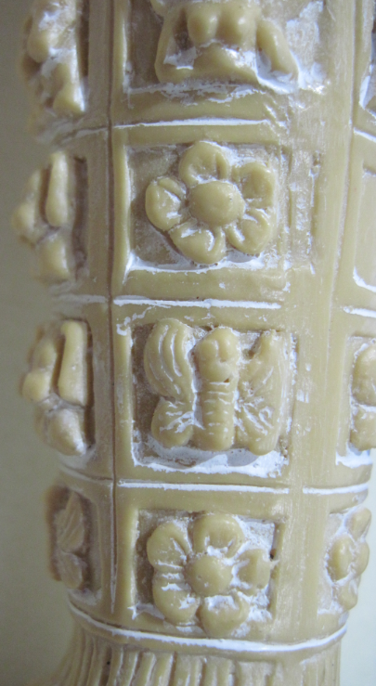 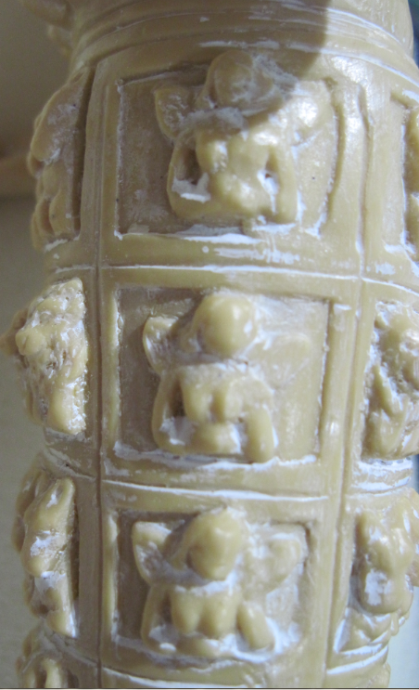

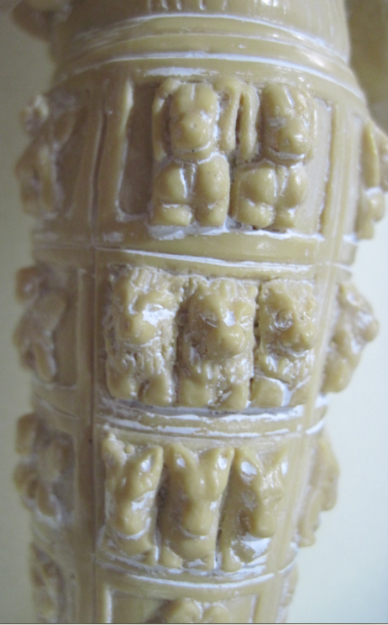 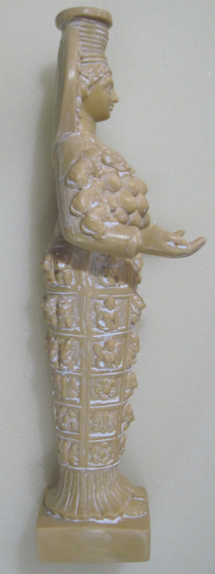 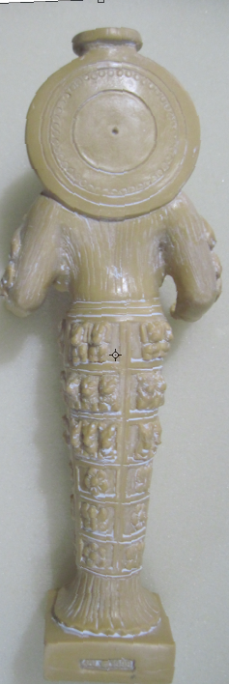 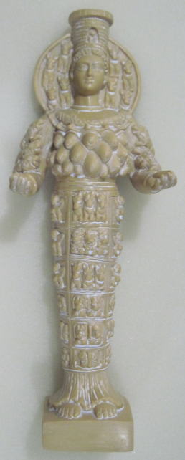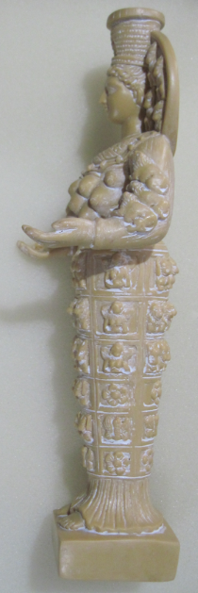

Figs. 1-11.

**Case no.: 4**

**Accession Number: A1130**

**Formal Label: Artemis of Ephesis-**7th century BCE replica

**Display Description:**

In Ephesus Artemis was originally venerated as “wild nature” in an open-air tree sanctuary, suggesting that the earliest statues of her were made from the Turkish Oak *Quercetum frainetto-cerris* Rud and sculpted into a pillar figure, which was maintained by local sculptors.

The city of Ephesus was built in the 10th century BCE on the site of the former Arzawan capitalby Attic and Ionian Greek colonists. During the Classical Greek era (5th and 4th centuries BCE) it was one of the twelve cities of the Ionian League. The city flourished after it came under the control of the Roman Republic in 129 BCE.

The city was famed for the nearby Temple of Artemis (completed around 550 BCE), one of the “Seven Wonders of the Ancient World” (Ring, Trudy and Salkin, Robert. 1995. "Ephesus". International Dictionary of Historic Places: Southern Europe. London: Fitzroy Dearborn, p. 217).

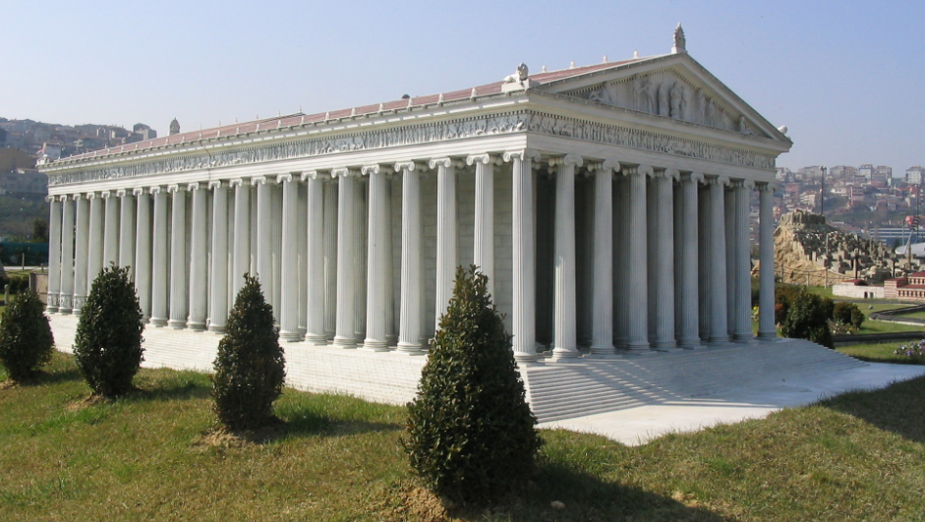

Fig. 12. A replica of the Temple of Artemis of Ephesus in Turkey. Note the probable use of the wood from the *Quercetum frainetto-cerris* Rud. or Turkish oak for the Ionic columns, which would literally have reproduced the forest of trees where Artemis once had her outdoor shrines. From https://upload.wikimedia.org/wikipedia/commons/1/1d/Miniaturk_009.jpg

This sculpture is based on a 7th century replica, which was one of the most popular. Artemis wears a polos crown representing Ephesus’ city walls with its entry gate in the center. Behind the crown is a nimbus or halo of the Sun disk with 4 sphinx protomes (προτομή) representing the upper part of sphinxes on both sides of her head. Originally this nimbus may have been only a decorated shawl, which the naked goddess could have covered herself. The eight sphinx protomes indicate that this is a replica of the sculpture in the Naples Museum, and they and the Sun disk suggest her connection to the Egyptian pantheon. Her braided hair is worn up, but in a Basel Museum copy the hair is worn loose in strands over her shoulders which is probably older suggestive of her “wild nature.”. Her hands are turned upwards which simultaneously suggest giving and receiving, which may have held wool (a symbol of giving) that drooped to the ground. In each upraised hand sat falcons, her favorite wild predators. Her breast is covered by a crescent-shaped *lunula* from which hang acorns of the Turkish oak, *Quercetum frainetto-cerris* Rud. This reinforces the upright structure of her stature which was sculpted from these straight-trunked trees and of the visual aspect of the tall, straight oak tree glades that once harbored her sanctuaries. Her lower body (*ependytes*) has six panels of animal protomes with sirens, rosettes, sphinxes and bees.

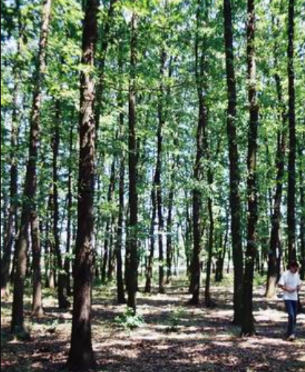 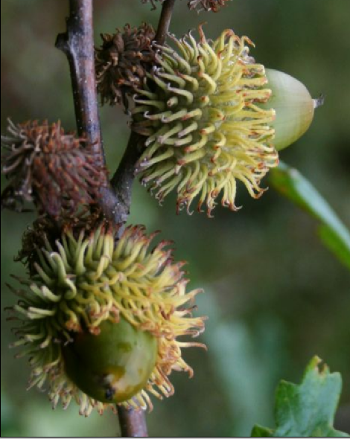

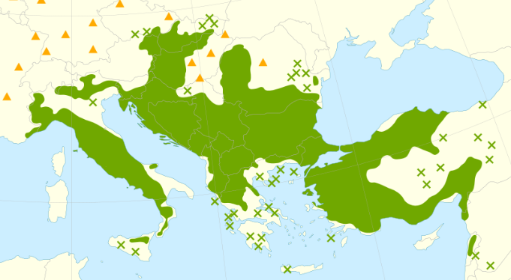

Fig. 13. Glade of *Quercetum frainetto-cerris* Rud. (from *By Stefanst at English Wikipedia, CC BY 2.5,* [*https://commons.wikimedia.org/w/index.php?curid=5985839I*](https://commons.wikimedia.org/w/index.php?curid=5985839I)*).*

Fig. 14. *Quercetum frainetto-cerris* Rud. Acorn shell that is repeated in the crescent-shaped lunula on her breast (after <https://upload.wikimedia.org/wikipedia/commons/b/b1/Quercus_cerris_5.jpg>).

Fig. 15. Distribution map of *Quercetum frainetto-cerris* Rud from Caudullo, Welk, San-Miguel-Ayanz, 2017.  See also for distribution of *Quercetum frainetto-cerris* Rud in Turkey from Browicz, K., Zieliński, J. 1982, *Chorology of trees and shrubs in south-west Asia and adjacent regions*, vol. 1. Warsaw, Poznań: Polish Scientific Publishers.

**LC Classification:**  DF221.E5

**Date or Time Horizon:** ca 232 BCE

**Geographical Area:** Ephesus

**Map, GPS coordinates:**  37.941111,27.341944; [37°56′28″N 27°20′31″E](https://tools.wmflabs.org/geohack/geohack.php?pagename=Ephesus&params=37_56_28_N_27_20_31_E_type:landmark)

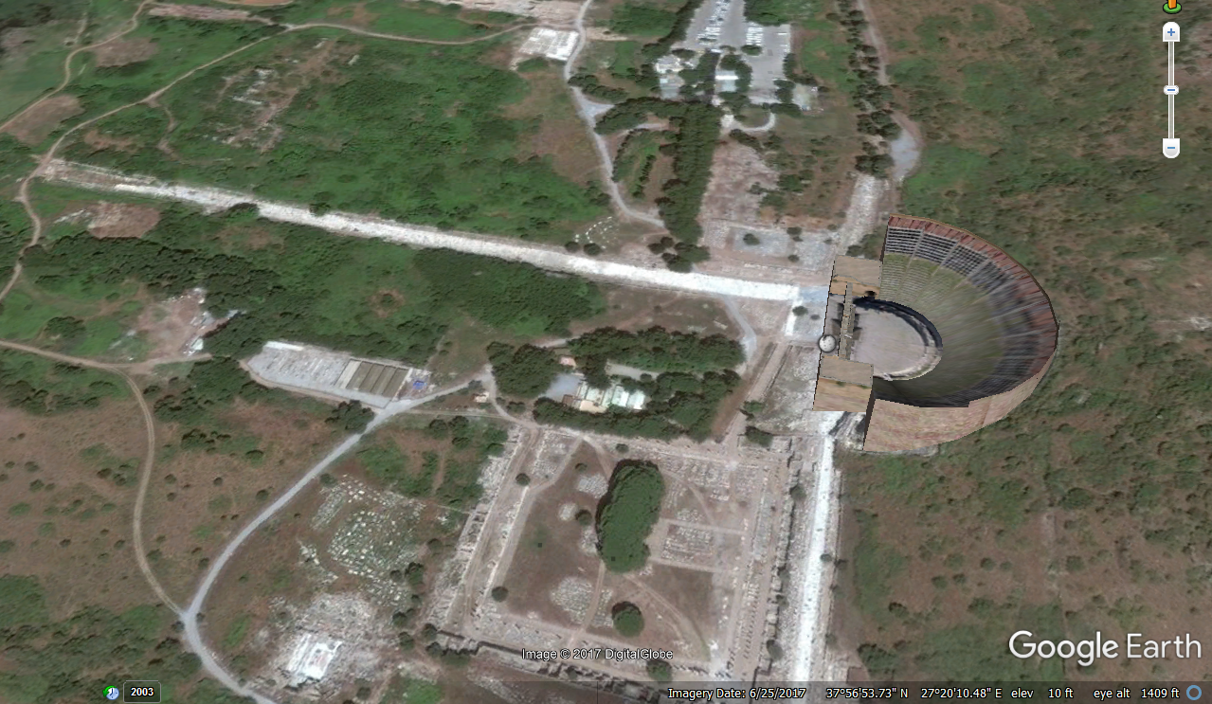

Fig. 16. View of the partially reconstructed amphitheater of Ephesus near where the ancient Temple to Atremis was located. After Google Earth map.

**Cultural Affiliation:** Greek

**Medium:** marble

**Dimensions:** n/a

**Weight: n/a**

**Condition:** miniature **replica of Naples Museum copy**

**Provenance:** miniature **replica of Naples Museum copy**

**Discussion:**

The worship of Artemis gradually developed into *Potnia Aswiya*, the cult of vegetation and fertility (Morris 2000: 425–428). Gradually it came to resemble its Greek counterpart *Potnia Theron*, the Mother of Animals. Alexander the Great, after his triumph at the Battle of Granicus in 334 BCE, entered Ephesus and proclaimed the Temple of Artemis one of the “Seven Wonders of the World.” After Alexander's death in 323 BCE, Ephesus came under the rule of one of Alexander's generals, Lysimachus, in 290 BCE. As the river Cayster (*Κάϋστρος*) began to silt up, marshes that replaced the harbor, produced malaria infested Anopheles mosquitos, which caused many deaths. Since the ancient city surrounded the temple of Artemis, Lysymmachuis removed the people to the present city two km (1.2 miles) away (Strabo. 1923–1932, pp. 14.1.21.), but the people were restless at having to be removed so far from their Temple.

**References:**

Caudullo, G., Welk, E., San-Miguel-Ayanz, J., 2017. Chorological maps for the main European woody species. Data in Brief 12, 662-666. DOI: [10.1016/j.dib.2017.05.007](https://doi.org/10.1016/j.dib.2017.05.007).

Morris, Sarah 2000. "Potnia Aswiya: Anatolian Contributions to Greek Religion" (PDF). In Laffineur, Robert; Hägg, Robin. [*Potnia: Deities and Religion in the Aegean Bronze Age: Proceedings of the 8th International Conference Göteborg*](http://www.ulg.ac.be/archgrec/aegaeum22pdf.html#pdf). Université de Liège: Aegeum 22 2001, pp. 425–428.

Strabo. 1923–1932. Geography, volumes 1–7. Cambridge: Loeb Classical Library, Harvard University Press.